INSTRUCTION MANUAL FOR MINI. INCUBATOR
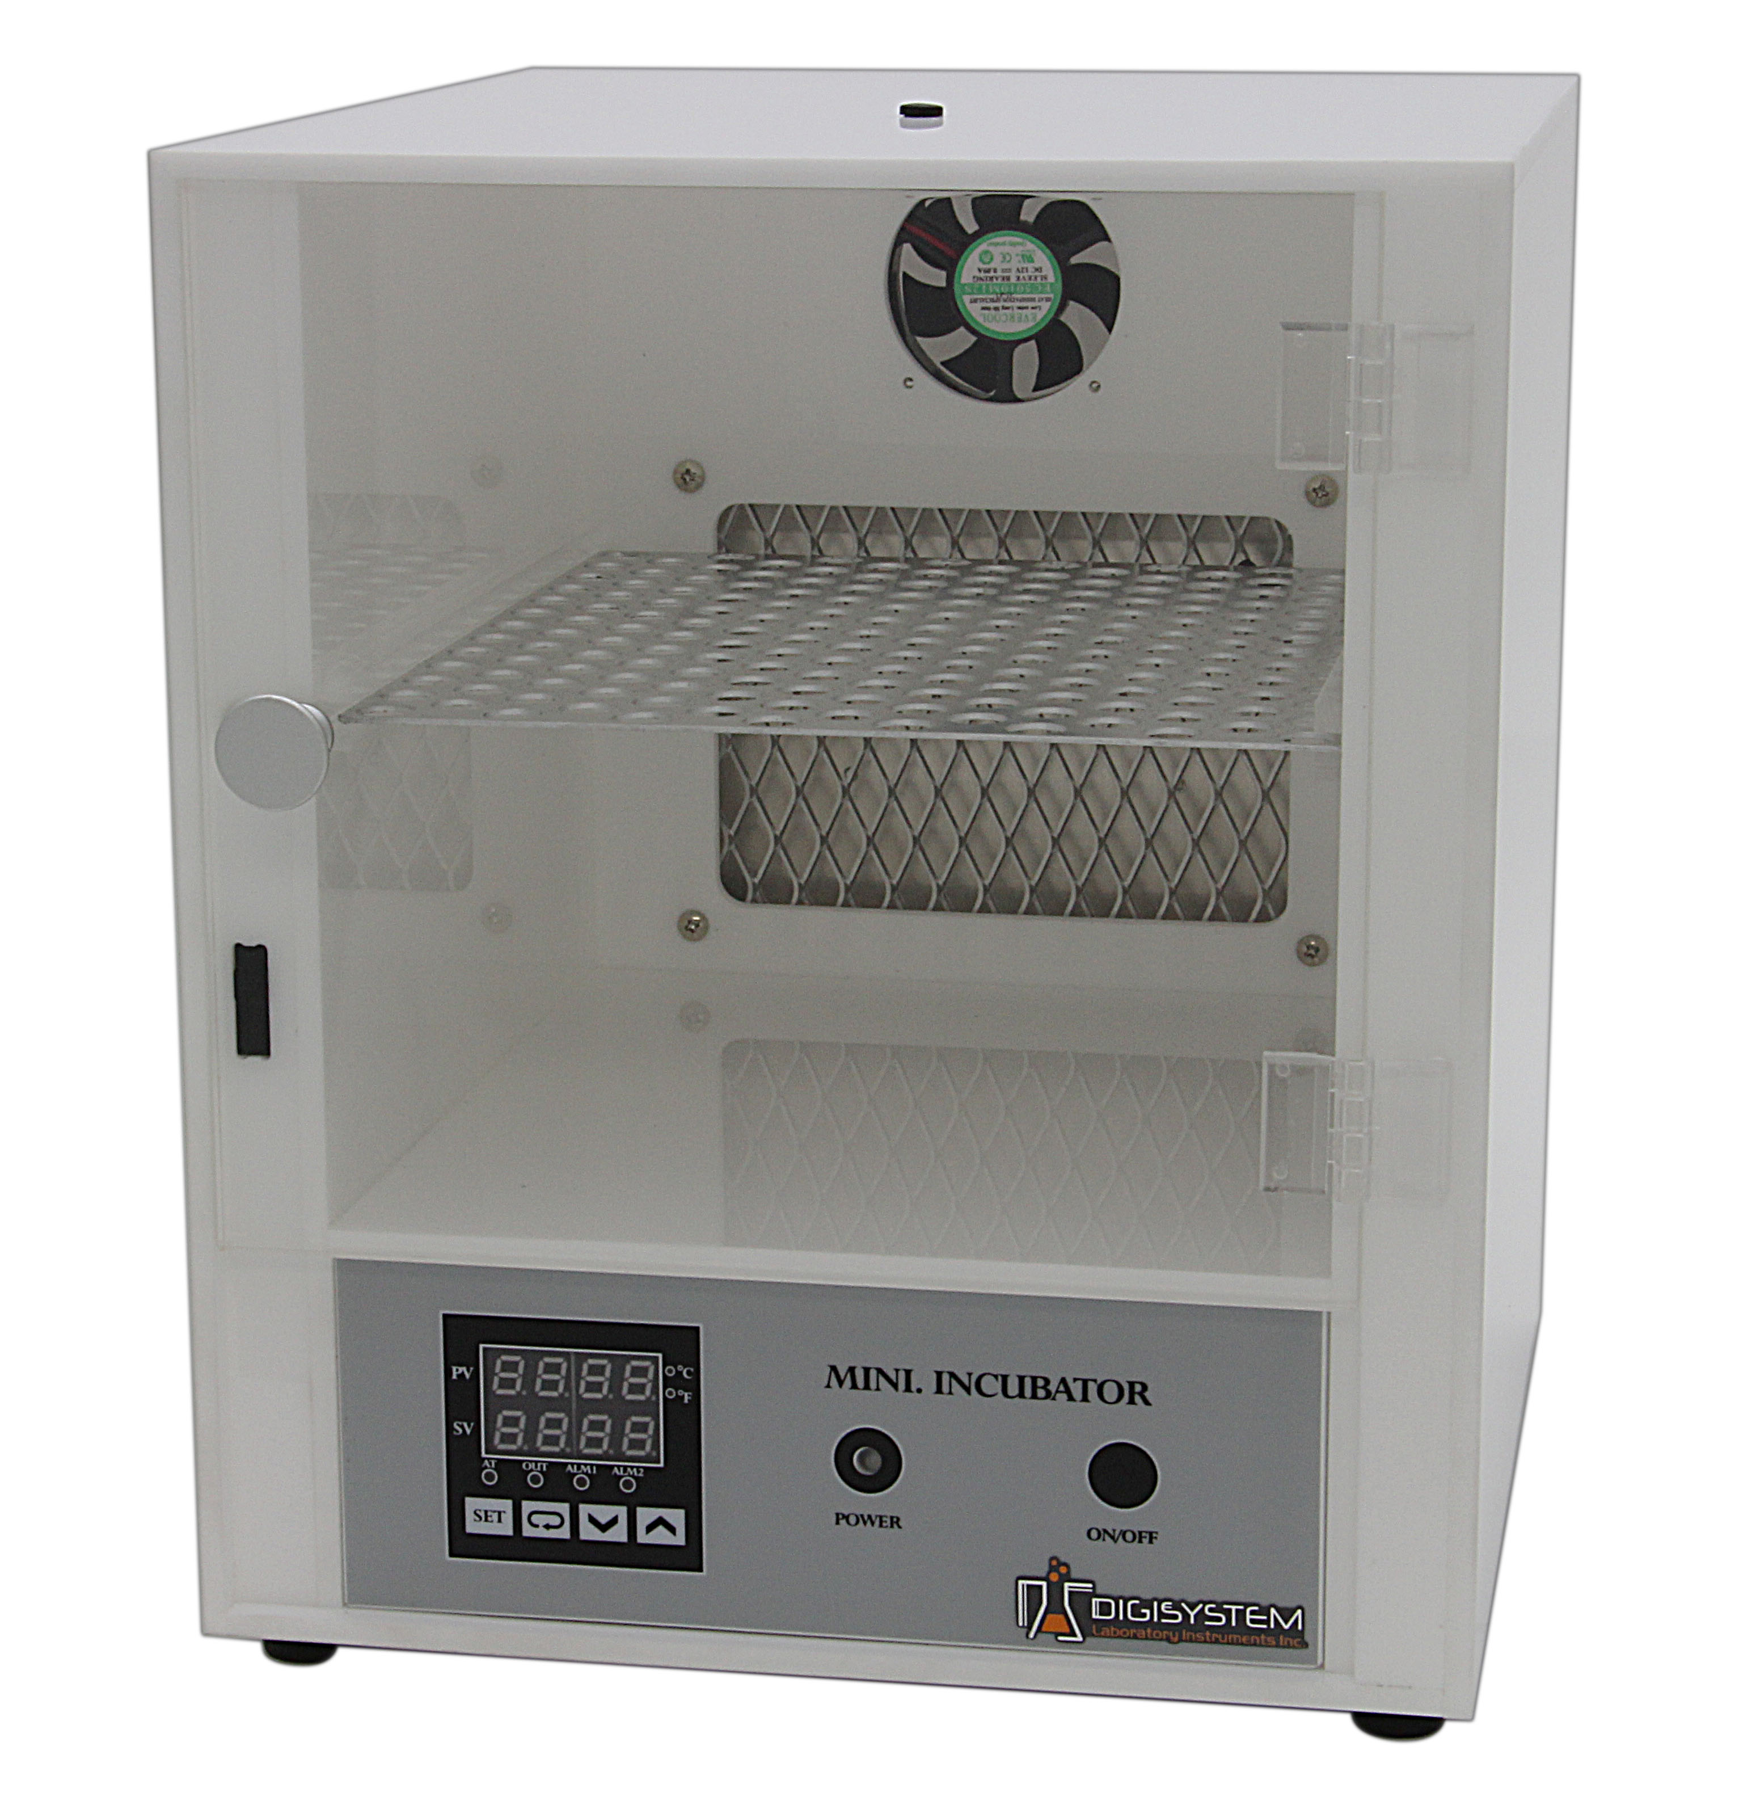

Fan
Door

ON/OFF switch
PID controlled panel

Power indicator

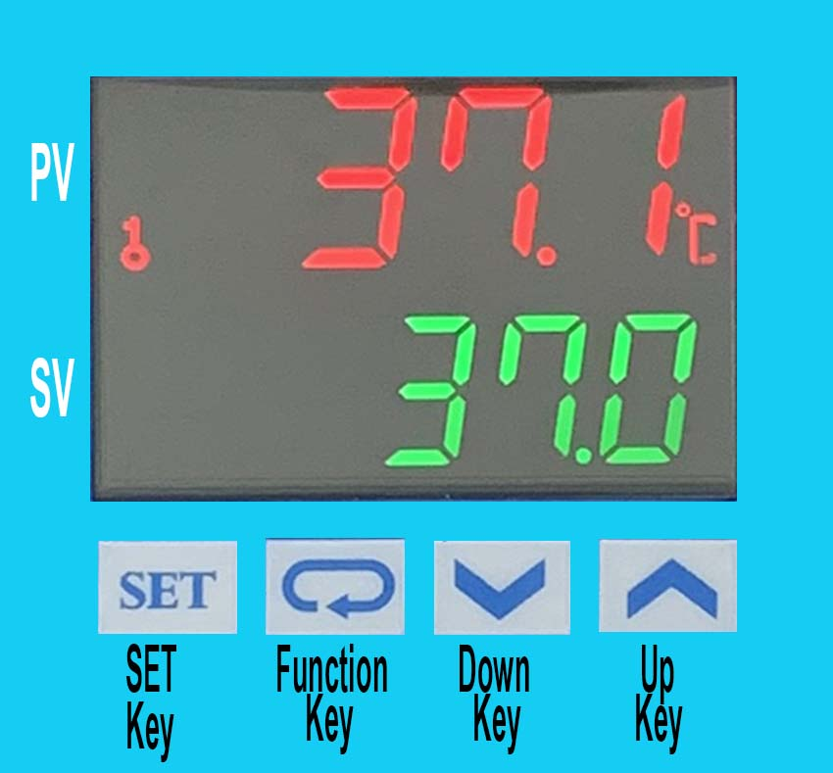
1. Connect with power supply. Please make sure the power voltage is the same as the voltage shown on the label stuck on the back of machine.
2. Put your sample in and close the door.
3. Press “ON/OFF Button”, then you will see the “Power indicator’ becomes green. The fan starts to rotate. Wait for about 5 seconds; you can see from PID control panel the present temperature value (PV) in upper row and setting temperature value (SV) in lower row.
4. Press “Up Key” or “ Down Key” to adjust SV value and then press “SET Key” to enter the value.
5. After finishing the work, please press “ON/OFF Button” to turn off the power, and then the “Power indicator’ becomes red.
Caution:
1. Make sure that the door is closed well to prevent heat loss and power drain.
2. Do not put any objects on the top of the instrument.
3. Please keeps the environment ventilated.

Remark:
1. When the “OUT” indicator is sparkling, it means that the instrument is heating.
2. After the PV value reaches to SV value and tends to be stable, the “ALM1” indicator lamp will light up if the PV value exceeds the SV value by setting point (10℃). In this situation, please turn the power off, open the door and wait for about 30 minutes, and then restart it.

Other functions:
Note: Before executing other functions, please follow “5. Setting locking status” ( c )to release the locking status. After executing other functions, please follow “5. Setting lock status” ( a ) and ( b ) to set the locking status to be LoC2.
- Setting point alarm:
  - Setting upper-limit point for the alarm: (when the difference between PV and SV is over upper-limit, the “Alarm Indicator “ (ALM1) will light up.)


    - Press four times. You will see in upper row and the setting value in lower row.
    - Press Up or Down key to set value, and press to enter the value. Press again to be back the PV/SV display.
    - The initial value is 10.
  - Setting lower-limit point for the alarm: (when the difference between PV and SV is over lower-limit, the “Alarm Indicator “ (ALM1) will light up.)
    - Press five times. You will see in upper row and the setting value in lower row.
    - Press Up or Down key to set value, and press to enter the value. Press again to be back the PV/SV display.
    - The initial value is 10.
- Setting temperature unit:

  - Press more than 3 sec., until you see in upper row.

  - Press once. You will see in upper row and the setting value in lower row.
  - Press UP or Down key to set temperature unit to be “C” or “F”, and press to enter the value. Press again to be back the PV/SV display.
  - The initial value is C.
- Setting PV shift (offset) value: (if the PV value is not correct, you can use this function to correct the PV value.)

  - Press once, and then you will see in upper row.

  - Press seven times, and you will see in upper row and the setting value in lower row.
  - Press Up or Down key to set shit value，and press to enter the value. Press again to be back the PV/SV display.
  - The initial value is 0.
- Setting Auto-tuning function:
  - Press Up or Down key to set SV value to be auto-tuning. Press to enter the value.
  - Press once.
  - You will see in upper row and the setting value in lower row.
  - Press UP or Down key to choose “ON” to start or “OFF” to close auto-tuning function. When auto-tuning function is on, you will see the “AT” indicator blanking. Once the auto-tuning function finish, the light of “AT” will extinguish.
  - The initial value is OFF.
Note: (Auto-tuning function is that PID controller can depended on the ambient air temperature to find the best way to reach the setting temperature and let the setting temperature keep stable.

- Setting locking status:

  - Press three times, and then you will see in upper row and the setting value in lower low.
  - Press Up or Down key to select the locking status. LoC1 can lock all settings； LoC2 can lock others than SV. When OFF is selected, the lock function will be off. After selecting, press to enter the value. Press again to be back the PV/SV display.


  - Press and simultaneously, and you see in upper row. Press , and you will see 0000 in the low row and then press . The key symbol will disappear from the screen. Then the locking status is released.
  - The initial value is LoC2.
- During the process of setting values, you may press anytime to be back PV/SV value.

SERVICE MANUAL
Caution: Always disconnect the power cord before troubleshooting.
Trouble | Cause | Remedy
Instrument inoperative | Power cord not connected to outlet. | Plug instrument in..
Instrument inoperative | Dead power output. | Change to different output.
Instrument inoperative | No fuse Breaker is off | Press the breaker back of the machine, and check if the current is overload.
Instrument inoperative | Electronic element broken | Contact your distributor for repair.
Instrument inoperative | Power switch is broken | Replacing a power switch
Controller can’t control the temperature | Sensor is broken | Replacing a sensor
Controller can’t control the temperature | PID controller | Replacing a PID controller
Controller can’t control the temperature | Heater is broken | Replacing a heater
The key of PID controller can’t work | The keys has been locked | Please refer to page 2, Other functions 5. © to release the lock status.
Temperature is not stable | The initial setting value is not suitable for the ambient air temperature where the machine is located | Please refer to page 2, Other functions 4. To set auto-tuning function to solve this problem.
PV value is not correct | User’s calibration thermometer is different from the factory’s calibration thermometer | Please refer to page 2, Other functions 3 to adjust PV value
The fan can’t work | The door isn’t close well. | Make sure the door is closed well.
The fan can’t work | The fan is broken. | Changing a fan.

CIRCUIT DIAGRAM


